# The Westcar Payprus (P. Berlin 3033)

## Notes by Minh-Tâm Trinh

I warmly thank Mary Becker, Galen Goldsmith, Rachel McEnroe, Foy Scalf, Dawn Schreiner, and Eric Whitacre for their input.

*Glossing Conventions*

(May not match the conventions in my older notes)

( ) text omitted by the scribe, but implicitly understood

< > addition to fix a scribal error

{ } deletion to fix a scribal error

[ ] addition to fix lacuna, or addition uncertain

*Sources*

[dB] *Egyptian Reading Book, Vol. 1: Exercises and Middle Egyptian Texts.* Ed. A. De Buck. Nederlandsch Archaeologisch-Philologisch Institut, Leyden (1948).

[B] R. H. Barnhart. “Papyrus Westcar – Berlin Papyrus 3033”. <https://archive.ph/JFc1i> archived from <https://rhbarnhart.net/Westcar_trans_web.html>

[C] J.-P. Crosefinte. « Essai de reconstitution du papyrus Westcar en écriture cursive ». <https://archive.ph/lvKuC> archived from <http://ecriture.egypte.free.fr/ressources/Westcar_2a.pdf>

*Other References*

[Faulkner] R. O. Faulkner. *A Concise Dictionary of Middle Egyptian*. Griffith Institute, Ashmolean Museum, Oxford. Reprinted at the University Press, Oxford (1981).

[Gardiner] A. Gardiner. *Egyptian Grammar: Being an Introduction to the Study of Hieroglyphs*. 3rd Edition, Revised. Griffith Institute, Ashmolean Museum, Oxford. Printed at the University Press, Cambridge (2007).

[Hoch] J. E. Hoch. *Middle Egyptian Grammar*. SSEA Publication XV. Benben Publications, Mississauga (1997).

[Schrauder–Laudenklos] F. Schrauder & J. Laudenklos. *Neue Palaegrafie des Mittelaegyptischen Hieratisch*. CreateSpace Independent Publishing Platform (2014).

Red text indicates rubric text in P. Berlin 3033.

**4/23–4/30/23**

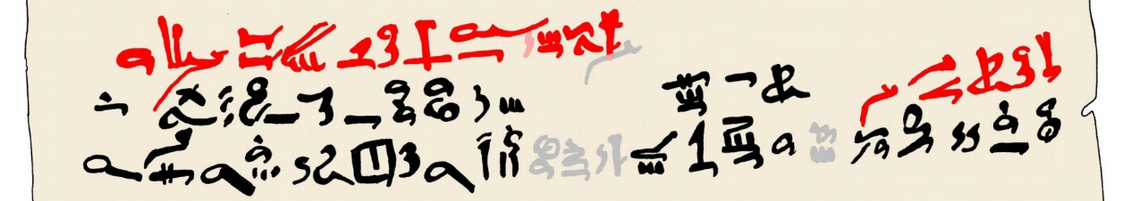

6.22 =f] aHa p[w] ir.n sA nsw tn @r-DD-f r

23 mdw.t Dd=f […]

[=i n sp] […]

[-.w] m rx.t n nty.w swA[=sn]

n

24 rx.n tw mAa.t r grg.w

[iw wn Hr] @m=k m hA.w=k Ds=k

6.22 …] Then this king’s son, Hordjedjef, stood up [“A standing-up was what this Prince Hordedef did”] to

23 speak [r + infinitive] [w.t by Schrauder–Laudenklos 24?], saying: […] […a time] […]

[…] as the knowledge [Faulkner 152] of the ones which have passed by [Faulkner 216, Hoch 281].

One does not

24 know [present-tense negation, Hoch §108] truth [*maat*] [determinatives illegible] from falsehood.

[There is, upon] Your Presence [Gardiner G7], in your very own time [Faulkner 157, Hoch 270],

**5/7/23**

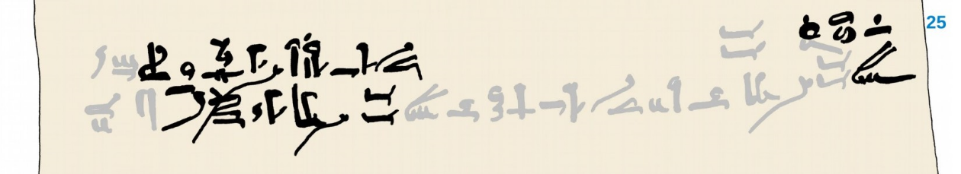

25 n rx[=k] […] [DD] […]

Dd in @m=f

iSs.t [pw]

26 @r-[DD-f sA=i]

[Dd=in sA nsw tn @r]-DD-f

iw wn nD[s]

25 before you [*contra* dB!] knew [Hoch §155, because n must be modifying a verb, not a noun] […] [-djedj-] […]

Then His Presence said:

What [Faulkner 31] is it,

26 Hor[djedjef, my son?]

[Then spoke this king’s son, Hor]djedjef:

There was a common[er] [determinatives illegible],

**5/14/23**

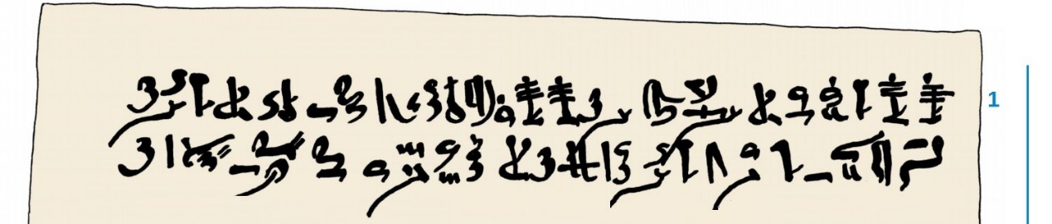

7.1 +di rn=f

Hms=f m +d-%nfrw mAa xrw

iw=f m

2 nDs n rnpt 110

iw=f Hr wnm m t 50[0?]

rmn n iH m

7.1 Djedi [Gardiner R11] his name [the =f clashes with the succeeding Hm-],

[for] he dwelt [Faulkner 170] [Gardiner N41-S29] in Djed-Sneferu [curved lines denote the cartouche oval; vertical line denotes the cartouche base], justified.

He is [“as”]

2 a commoner [badly written n and s] of 110 years [of age].

He subsists [present progressive] in 50[0?] [loaves of] bread,

a shoulder [Faulkner 149] of beef [Faulkner 28] [Gardiner E1] as

**5/21/23**

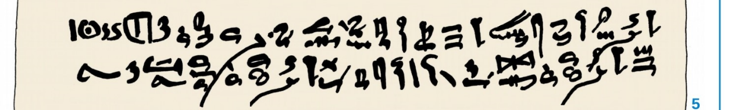

3 iwf

Hna=s swr Hnk.wt 100 d[s]

r-mn-m hrw

4 pn

iw=f rx(w) Ts tp Hsq(w)

iw=f rx(w) rdi.t Smi

3 meat [Faulkner 13],

[along] with drinking [Faulkner 217] 100 jars [Gardiner I10, not D46] of beer

as far as [Faulkner 106] this

4 day.

As for him, he knows [stative] [badly written x] how to bind [“the binding of”] [Gardiner S24] a severed [Faulkner 178] head.

As for him, he knows [stative] how to cause [“the causing that”] a lion

**5/28/23**

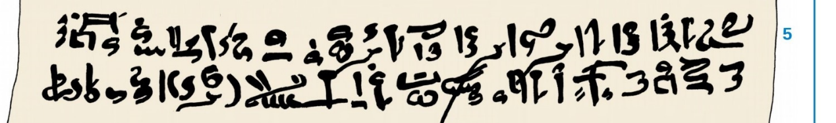

5 mAi Hr sA=f

sSd=f Hr tA

iw=f rx(w) tnw ip.wt

6 n.t wn.t n.t +Hwty

is.t wrS @m n Nsw Bity #fw mAa-hrw

5 go at [“upon”] his backside,

his leash [Gardiner V12] upon the ground.

As for him, he knows [stative] the number [Faulkner 305] [Gardiner T14] of chambers [Faulkner 16–17] [Gardiner O45]

6 of the sanctuary [Faulkner 61] of Thoth.

Then the Presence of the King of the Two Lands, Khufu, justified, spent the day [Faulkner 65]

**6/4/23**

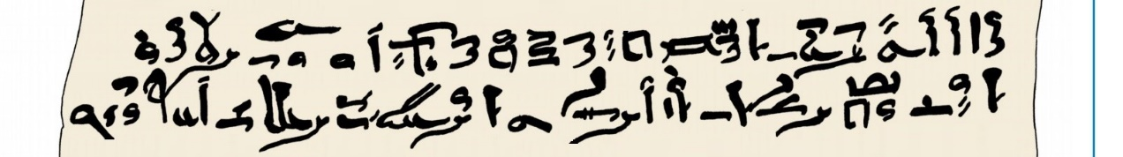

7 Hr HHy n=f nA n ip.wt n.t wn.t n.t +Hwty

r ir.t n=f mit.t

8 iry n Ax.t=f

Dd.in @m=f

Ds=k irf @r-DD-f sA=i

in.t{w}=k

7 upon searching [pseudoverbal as gerund?] [Faulkner 176] for him[self] that of the chambers of the sanctuary of Thoth,

in order to make for him[self] the likeness

8 thereof [Hoch 259] for [dative n, but written with Gardiner D35] his tomb [Faulkner 5].

Then His [f underneath the following s] Presence said:

You yourself [vocative], too[? Faulkner 28], Hordjedjef, my son:

You bring [variant spelling of perfective ini, according to Gardiner 365] [lexical hyper-correction?]

**6/11/23**

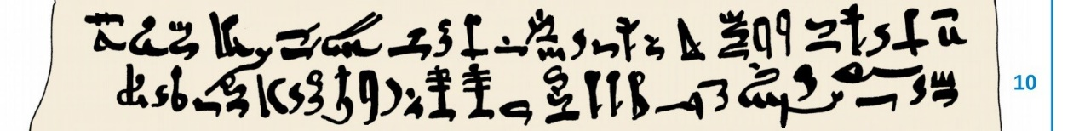

9 n=i sw

aHa.n Sspd aHa.w n sA nsw tn @r-DD-f

SAs

10 pw ir.n=f m xnti r +d-%nfrw mAa xrw

9 him to me.

And then ships [Faulkner 48] [possible pun with aHa.n?] were made ready [Faulkner 245] for [dative Gardiner D35] this king’s son, Hordjedjef.

A journey [Faulkner 261]

10 is what he took [“made”] into the south [Faulkner 195] toward Djed-Sneferu, justified.

**6/18/23**

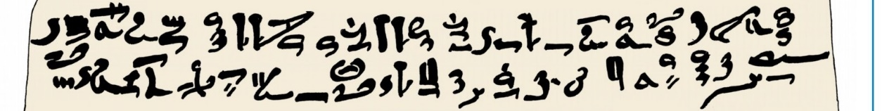

11 xr m-xt nA n aHa.w mni r mry.t

SAs pw

12 ir.n=f m H(r).ty

snDm.n=f m qniw n hbny nbA.w

11 Now after [compare to Hoch 92–93] [Gardiner A15] these [“of the”] ships had been moored [stative?] [Faulkner 107] at [“against”] the riverbank,

a journey is

12 what he took [“made”], travelling by land [“as travel by land”] [Faulkner 176],

[once] he had been seated [circumstantial sDm.n=f?] [Faulkner 235] [Gardiner M29] in a palanquin [Faulkner 280] [Gardiner D32?] of ebony [cognate!] [Faulkner 158] [Gardiner U13], [with] poles [Faulkner 130]

**6/25/23**

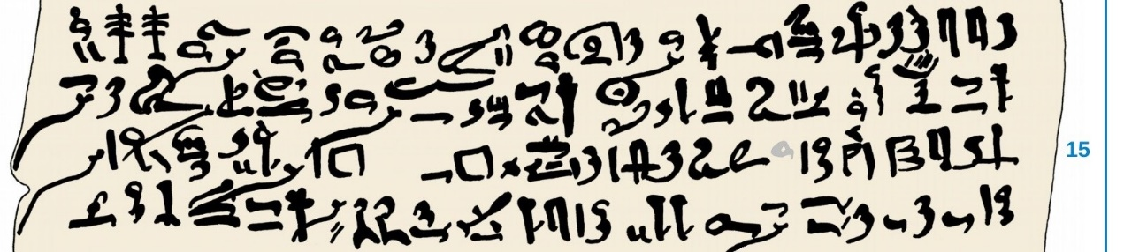

13 m ssnDm gnX(w) rf m nbw

xr m-xt spr=f r +di

14 aHa.n wAH.(w) pA qniw

aHa pw ir.n=f r wSd=f

gmi.n=f

15 sw sDr Hr [t]mA m sS pr n [?] pr=f

Hmw Xr tp=f

16 Hr amam n=f

ky Hr sin rd.wy=f

aHa.n Dd.n sA nsw tn

13 as [of] *sesendjem* wood [Faulkner 245] [pun on snDm in line 12?], now mounted [stative] in [Faulkner 290] gold.

Now after he had reached Djedi [compare to line 11],

14 [“then”] the palanquin was set down [past passive] [Gardiner V29].

A standing-up was what he did, in order to address him,

[when] he had found

15 him laying [Faulkner 259] upon a mat [Gardiner V19] on the threshhold [Faulkner 246] [?] of his house,

[where] a servant was upon his head,

16 anointing [Faulkner 42] [“for”] him,

another rubbing [Faulkner 213] his legs.

And then spoke this king’s son,

**7/2/23**

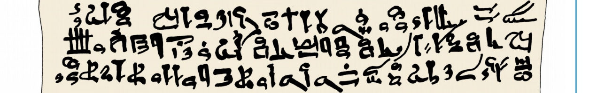

17 @r-DD-f

iw xr.wt=k mi anx tp m tni

xr iAw.t

18 st mny st qrs st smA-tA

sDr r Ss-

19 -p

Sw m xAy.wt

nn kHkH.t nt sry.t

nD-xr.-

17 Hordjedjef:

Your condition [Faulkner 195] is like living before [“at the head of”] growing old [Faulkner 299],

[and] further [Faulkner 195] [Hoch §185(3)], upon old age [Faulkner 8],

18 the seat [Gardiner Q1] of [*idaafa*] the mooring-post [Faulkner 107] [euphemism for and pun on mni, “death”, Faulkner 108], the seat of burial, the seat of uniting-[with]-earth,

[yet] sleeping till the da-,

19 -wn,

freed [Faulkner 263] of diseases [Faulkner 183],

without the hacking [Faulkner 287] of a cough [Faulkner 235].

Greetings [Gardiner Aa27] [Faulkner 144, 195],

**7/16/23**

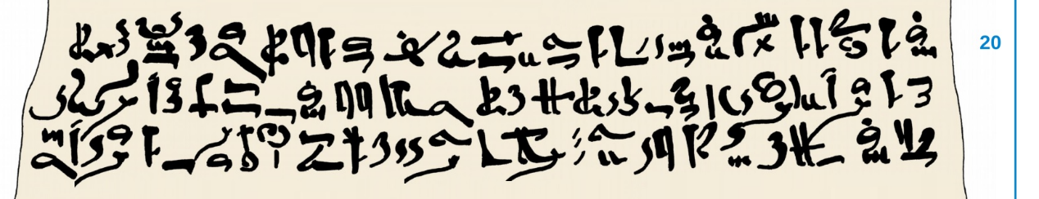

20 -.wt imAxy pw

ii.n=i aA r nis r=k m wpw.t

21 nt it=i #fw mAa xrw

wnm=k Spss.w n rd.wy nsw tn

DfA.-

22 -.w n imi.w Sms.w=f

sbi=f tw m aHa.w nfr n it.w=k

20 it is the revered one [Faulkner 20] [vocative pw?].

That I have come [second tense], great [one], is to summon [Faulkner 126] you by [“in”] the command

21 of my father Khufu, justified.

May you eat [prospective] delicacies [Faulkner 265] [out] of the hands of this king,

provision- [Faulkner 322]

22 -s [out] of the placements [Faulkner 19] [visual pun with wnm in line 21?] of his followers [Gardiner T18] [parallel grammar].

May he conduct [prospective] [Faulkner 219] you through a beautiful lifetime [Faulkner 48] to your ancestors

**7/23–7/30/23**

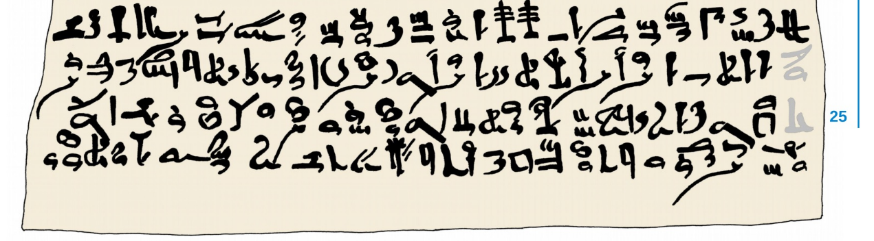

23 imi.w Xr.t-nTr

Dd.in +di pn

m Htp sp sn @r-DD-f sA nsw tn

24 [mr]y n it=f

Hs tw it=k #fw mAa xrw

sxnti=f

25 [s]t=k m iAw.w

Sn{t}<i> kA=k x.wt r xf.t=k

rx bA=k

26 wa.wt afd.t r sbx.t n.t Hbs bAg

nd-xr.wt

23 [?] the necropolis.

Then spoke this Djedi:

In peace (×2), Hordjedjef, this king’s son,

24 beloved of his father.

May your father, Khufu, justified, favor [prospective] [Faulkner 176] [Gardiner W14] you.

May he promote [“cause to go southward”] [Faulkner 242]

25 your place among the ancestors.

May your *ka* conjure [prospective] [Faulkner 268] things against your enemy.

May your *ba* know [prospective]

26 the roads, [those] that lead [participle] [Faulkner 42] toward the portal [Faulkner 220] of the shelter of the languid [Faulkner 79] [*idaafa*].

Greetings,

**8/6/23**

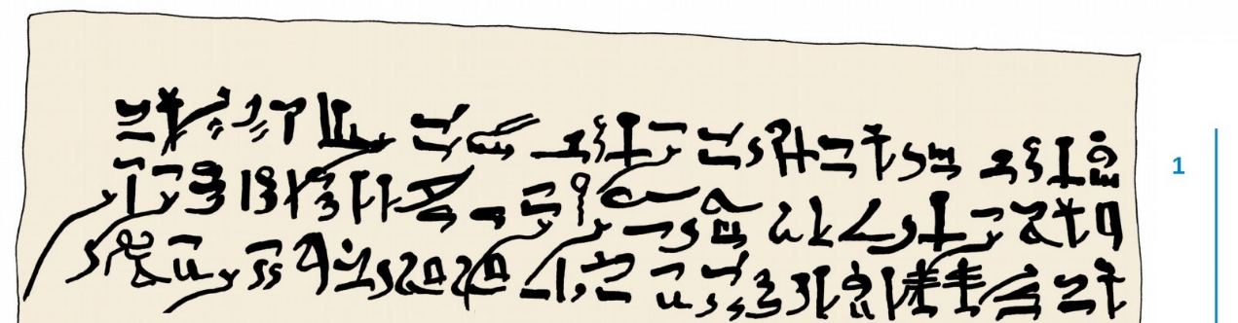

8.1 sA nsw tn pw

aHa.n Aw(y).n=f sA nsw tn @r-DD-f awy=fy

aHa.n

2 s-aHa.n=f sw

wDA pw ir.n=f Hna=f r mry.t Hr rdi.t n=f a=f

3 aHa.n Dd.n +di

im(i) di tw n=i wa.w n qAqA.w int{w}=f n=i Xrd.w

8.1 it is this king’s son.

And then this king’s son, Hordjedjef, extended [*contra* dB, the last sign is Gardiner D36, not n] his arms [Faulkner 1].

And

2 he raised him up.

[And] a journey was what he made with him, to the riverbank, [while he] was giving to him his arm.

3 And then Djedi said,

Cause to be brought [“that one brings”] to me one of the travel-barges [Faulkner 276], in order that it bring [prospective] [active not passive, but written with tw; see footnoote 5 on Hoch page 90] [my] children to me

**8/20/23**

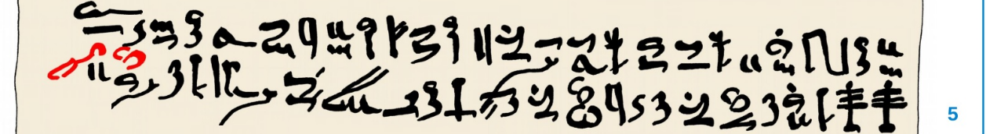

4 Hr sS.w=i

aHa.n rdi(.w) aHa n=f aHa 2 Hna is.t=sn

iw.t pw iri.n

5 +di m xd m wsx nty sA nsw tn @r-DD-f im=f

xr

4 upon my writing [“writings”].

And then two ships [Faulkner 48] were raised up [perfect passive] for him, along with their crews [Faulkner 30].

5 Djedi came [“A coming was what Djedi did”] traveling downstream [Faulkner 199] [Hoch §60] in the barge, that which [held] this king’s son Hordjedjef in it [relative].

Upon

**8/27/23**

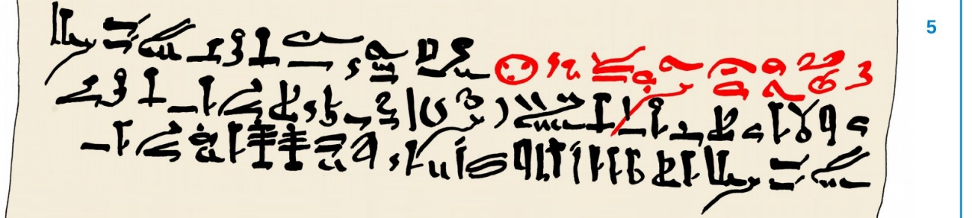

6 m-xt spr=f r $nw

saq pw ir.n sA nsw tn @r-DD-f

7 r smi.t n @m n Nsw Bity #fw mAa xrw

Dd.in sA nsw tn

8 @r-DD-f

i ity a(nx.w) w(DA.w) s(nb.w) nb=i

iw in.n=i +di

Dd.in

6 [or] after his reaching of [“unto”] The Residence,

an entrance [“a causing-to-enter”, Faulkner 215] was what this king’s son Hordjedjef made,

7 in order to go [compare to line 7.14] to the Presence of the King of the Two Lands, Khufu, justified.

Then spoke this king’s son

8 Hordjedjef:

O Sovereign [Faulkner 32–33] [Mary claims the initial i is a vocative, separate from ity; see Hoch, §64], [given] l[ife], p[rosperity], h[ealth] [implicit stative], my lord!

I have brought Djedi.

Then spoke

**9/3/23**

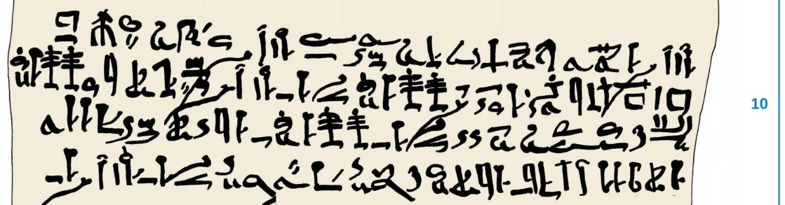

9 @m=f

is in n=i sw

wDA pw ir.n @m=f r wAxy n

10 Pr-aA a(nx.w) w(DA.w) s(nb.w)

sTA.in.tw n=f +di

Dd.in @m=f

pty st +di

11 tm rdi(w) mAA.n=i tw

Dd.in +di

nisw pw ii

12 i ity a(nx.w) w(DA.w) s(nb.w)

nis r=i

mk wi ii.kwi

Dd.in @m=f

in

9 His Presence:

Go [Faulkner 29], bring him to me.

[And] a journey was what His Presence made, to the forecourt [Faulkner 54] of

10 the Great House [“the Pharaoh”], [given] l[ife], s[tability], h[ealth].

Then Djedi was ushered in [Faulkner 255] [Gardiner U15] [passive, hence different from line 8.3] to him.

Then spoke His Presence:

How [“What”, Faulkner 96] is it, Djedi,

11 that I had not seen you [“that there was not causing that I had seen you”] [Hoch §164–165]?

Then Djedi said:

It is the one summoned [Faulkner 126] who comes,

12 O Sovereign, [given] l[ife], s[tability], h[ealth].

You summon [Faulkner 126] me.

Look, I have come [stative].

Then spoke His Presence:

Is

**9/10/23**

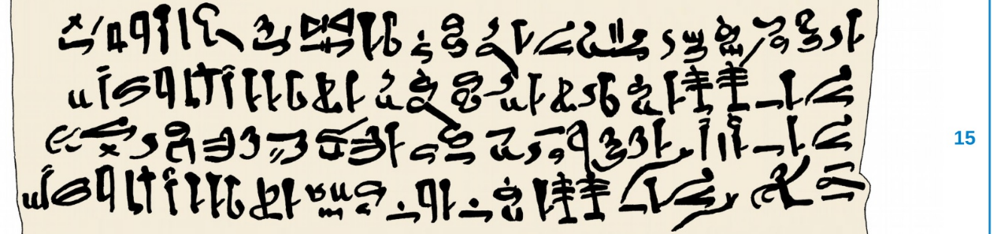

13 iw mAa.t pw pA Dd(w)

iw=k rx.ti Ts tp Hsq(w)

14 Dd.in +di

tiw

iw=i rx.kwi

i ity a(nx.w) w(DA.w) s(nb.w) nb=i

15 Dd.in @m=f

imi in.tw n=i xnri nty m xnr.t

wd

16 nkn=f

Dd.in +di

n is n rmT.wt

i ity nb a(nx.w) w(DA.w) s(nb.w) nb=i

13 it truth, that which is said:

For you, [it] is known [stative], the binding of a severed head [compare to line 7.4]?

14 Then Djedi said,

Yes [Faulkner 298].

As for me, it is known,

O Sovereign, [given] l[ife], s[tability], h[ealth], my lord.

15 Then spoke His Presence:

Cause to be brought [passive] to me a prisoner [Faulkner 193] of [those] in the prison.

Order [Faulkner 72]

16 his execution [Faulkner 141].

Then Djedi said,

Not so [Faulkner 30] to [Gardiner D35 for the dative n] people,

O Sovereign, [given] l[ife], s[tability], h[ealth], my lord!

**9/17/23**

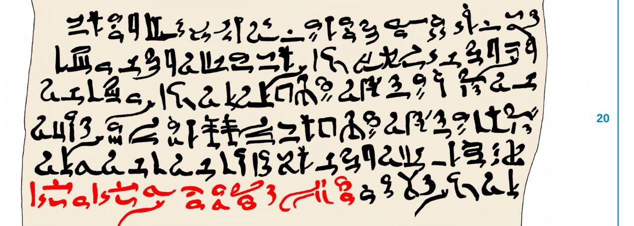

17 mk n wD.tw ir.t mn(t).t iry n tA aw.t Sps.t

aHa.n

18 in.n=f smn

wDa.<tw> tp=f

aHa.n rdi.(w) pA smn r g-

19 -bA imn.ty n wAxy

DADA=f r gbA

20 iAb.ty n wAxy

aHa.n Dd.n +di Dd.wt=f m HkA.-

21 -.w

wn.in pA smn aHa.(w) HbAHbA

DA-

22 -DA=f m mit.t

Xr m-x.t spr=f wa r wa

17 Look, it was not decreed [Faulkner 73–74] [different from the wd in line 8.15] [Hoch §107] to do the likeness [variant of mit.t, Faulkner 110] thereof to that of the noble [Faulkner 264] herd [Faulkner 39].

So then

18 he brought a goose,

[and] its head [was] cut off.

And then this goose was placed [stative] toward the western

19 side [Faulkner 288] of the forecourt,

its head [Faulkner 319] toward the eastern

20 side of the forecourt.

And then Djedi uttered his utterances of [“in”] magic-

21 -s.

And then this goose had stood up [past narrative stative, Gardiner §470], waddling [Faulkner 167] [appositive?],

its

22 head as well [“as the likeness”].

And further, after the one had reached the other [“the one”],

**1/7/24**

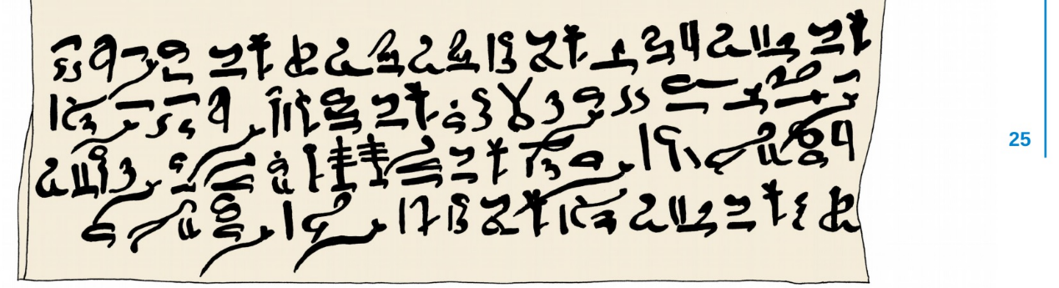

23 aHa.n pA smn aHa.w Hr gAgA

aHa.n rdi.n=f ini.tw

24 n=f x,t-aA

iri.n tw rf mit.t

aha.n rdi.n @m=f ini.tw n=f kA

25 sxr.<tw> tA=f r tA

aHa.n Dd.n +di Dd.wt=f m HkA=

26 =w

aHa.n pA kA aHa.w Hr sA=f sSd=f xr

23 then this goose had stood up [stative], cackling [appositive] [Faulkner 288].

And then he [the king] caused to be brought

24 to him another poultry-bird [Faulkner 199],

[and] the same was now done to it.

And then His Presence caused to be brought to him a bull,

25 [and] its head [was] thrown [Faulkner 242] to the ground [compare to line 18].

And then Djedi uttered his utterances of [“in”] magic-

26 -s.

And then this bull [had] stood up [stative] upon its hobble [Faulkner 207], its [??] upon

**1/14/24**

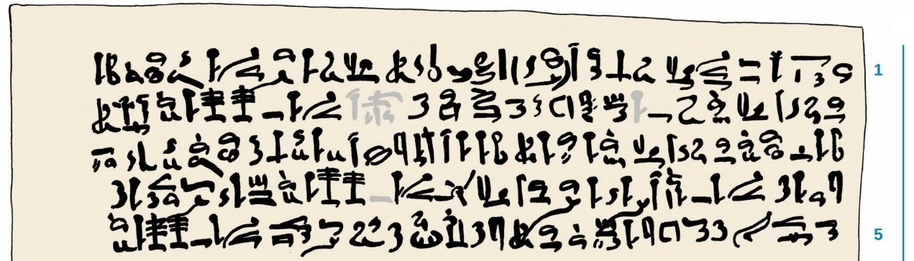

9.1 r tA

aHa.n Dd.n pA nsw #fw mAa xrw

pA irf Dd iw=k rx.ti

2 tnw nA n [i]p.wt nt wn.t nt [+Hwty]

Dd.in +di

Hs.-

3 -.ti

n rx tnw iry

i ity a(nx.w) w(DA.w) s(nb.w) nb=i

iw=i swt rx.kwi bw nty

4 st im

Dd.in @m=f

iw irf tn

Dd.i[n] +di pn

iw afd.t im

5 nt ds m a.t sipty rn=s m Iwnw

9.1 the ground.

And then this king Khufu, justified, said:

Now, this talk that [begins circumstantial clause] you know [stative]

2 the number of chambers of the sanctuary of Thoth [compare to lines 7.5–6]?

Then Djedi said,

May it

3 please you [Hoch §99]!

I do not know the number thereof.

O Sovereign, [given] l[ife], s[tability], h[ealth], my lord,

As for me, I know this [“it”]: the place

4 in which it is.

Then His Presence said:

Now then, where [Faulkner 305]?

Then spoke Djedi:

[It] is in a chest [Faulkner 42]

5 of flint [Faulkner 305] in a room [Faulkner 37], its name Investigation of Heliopolis [Faulkner 212] [appositive].

**1/28/24**

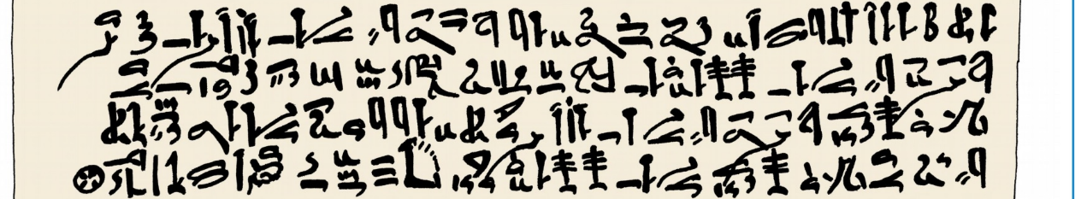

6 i ity a(nx.w) w(DA.w) s(nb.w) nb=i

mk nn ink is [pw] ini.n n=k sy

Dd.in @m=f

in-m irf

7 in(w)=f n=i sy

Dd.in +di

in smsw n pA Xrd.w

3 nty m X.t n Rd-

8 -Dd-t in(w)=f n=k sy

Dd.in @m=f

mr=i is s.t

nA Dd.y=k

pty

9 sy tA RdDd.t

Dd.in +di

Hm.t wab n Ra Nb %AXbw

6 O Sovereign, [given] l[ife], s[tability], h[ealth], my lord,

Look, it is in fact [Faulkner 30] not I who brings [Hoch page 154] it to you.

Then His Presence said,

Who [Faulkner 100] is it then

7 that [“he”] will bring [second-tense prospective sDm(w)=f, Hoch §138] it to me?

Then Djedi said:

By the eldest [Faulkner 229] of the three

ch[ild]ren of [those] in the womb [“belly”] of Rede-

8 djedet: He will bring [second-tense prospective sDm(w)=f] it to you.

Then His Presence said,

I in fact [Faulkner 30] wish it.

[As for] these [things] that you were saying [imperfect participle]:

Who [variant of ptr, Faulkner 96]

9 is this Rededjedet?

Then Djedi said:

Wife to a *wab*-priest of Ra, Lord of Sakhbu,

**2/11/24**

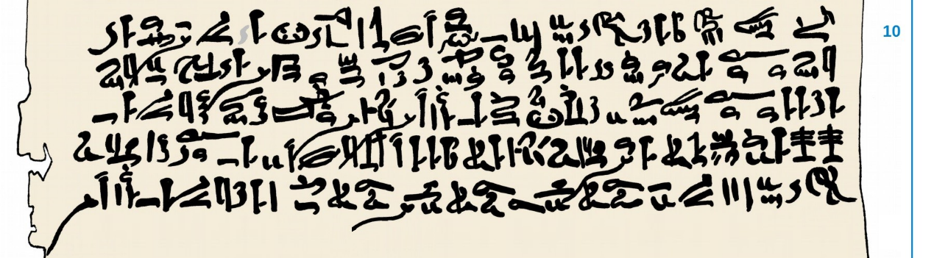

10 iwr.ti m Xrd.w 3 n Ra Nb %Axbw

i(w) Dd.n=f r=s

iw=

11 =sn r ir.t iA.t twy mnx.t m tA pn r Dr=f

iw smsw n sn

12 imy r ir.t Wr-MAw m Iwnw

wn.in @m=f ib=f wa.(w) r D.wt Hr=s

Dd.in

13 +di

pty irf pA ib

i iti a(nx.w) w(DA.w) s(nb.w) nb=i

in (iw) ir.tw Hr pA

14 Xrd.w 3 Dd.n=i

kA sA=k kA sA=f kA waw im=s

Dd.in @m=f

10 pregnant [Faulkner 13] [stative] with three children of Ra, Lord of Sakhbu.

He said regarding it:

Th-

11 -ey are going [pseudoverbal] to do this [Faulkner 295] excellent [Faulkner 109] function [Faulkner 7] across the land [“in the land to its limit”].

The eldest [Faulkner 229] belonging [Faulkner 19]

12 to them is going to [pseudoverbal] make Greatest of the Seers [high-priest of Ra] [Faulkner 64] in Heliopolis.

Then as for His Presence, his heart fell into sadness [Faulkner 320] upon this.

Then spoke

13 Djedi:

Wherefore this heart?

O Sovereign, [given] l[ife], s[tability], h[ealth], my lord,

is it made on account of [“upon”] these

14 three children [of whom] I spoke?

Your son [enclitic kA, Faulkner 283], his son, [and then] one among them.

Then spoke His Presence:

**2/25/24**

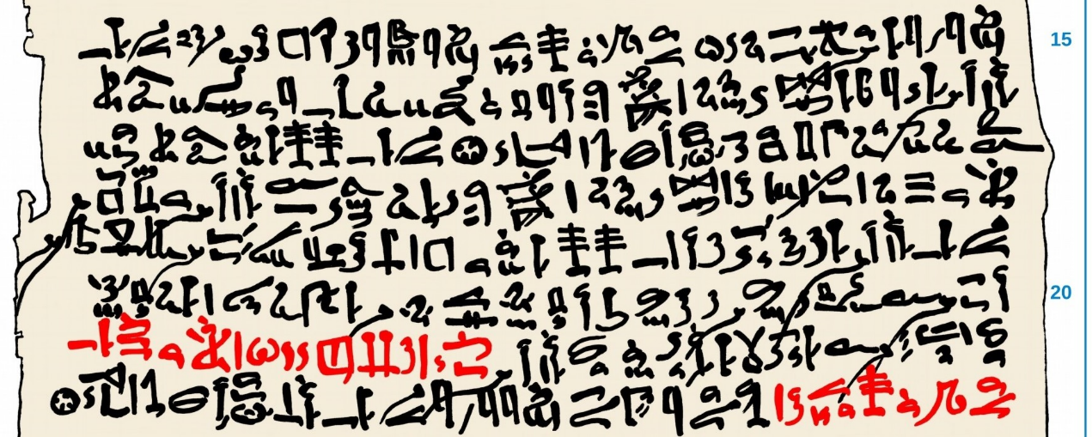

15 ms=s irf s(y) nw Rd-Dd-t

[Dd.in +di]

ms=s m Abd 1 pr.t (sw) 15

Dd.in

16 @m=f

iw isT *sw nw Rm.wy Hsq.(w)

bAk=i A n s.t Ds=i

kA

17 mA.n=i tA Xw.t-nTr nt Ra Nb %Axbw

Dd.in +di

kA rdi=i

18 xpr mw nw mH 4 Hr *sw nw Rm.wy

wDA pw ir.n @m=f r aH=f

19 Dd.in @m=f

imi di.tw m Hr n +di r pr sA nsw tn @r-DD-f

Hms=f

20 Hna=f

iri aq.w=f m t 1000 hnq.wt Ds 100 iwA 1 iAq.(w)t

21 xrSw 100

ir in.tw mi wD.t nb.t @m=f

wa.w m nn hrw xpr wn.in

22 Rd-Dd-t Hr Sn.t=s

15 Which [Faulkner 211, Gardiner 629] time [Faulkner 127] shall she give birth [Faulkner 116] [prospective] thereof, Rededjedet?

[Then Djedi said,]

She gives birth in month 1 of winter [Faulkner 91], day 15.

Then spoke

16 His Presence:

Now [Faulkner 253, 31], where[?] the Banks [Faulkner 307] of Two Fish [Faulkner 149] [Gardiner R12 signifies divinity?] end [“cut off”],

my servant [Faulkner 79] [vocative], I enter [Faulkner 1] [“to”] it myself.

[enclitic kA]

17 I would see [prospective?] the temple of Ra, Lord of Sakhbu.

Then spoke Djedi:

[enclitic kA] I shall cause [prospective]

18 to appear water of 4 cubits [high] upon the Banks of Two Fish.

[Then] His Presence set out [Faulkner 75] [“a setting-out was what His Presence made”] for his palace [Faulkner 46].

19 Then spoke His Presence:

Cause [spelling of imi listed on Hoch page 161] to be appointed [passive prospective], as what belongs to Djedi, toward the house of this king’s son, Hordjedjef.

He shall reside [prospective]

20 with him.

Make [imperative] his provisions as 1000 [loaves of] bread, 100 jars of beer, 1 ox [Faulkner 12], [and] vegetables [Faulkner 9]

21 in 100 bundles [Faulkner 197].

It was done [passive; compare to page 8, line 15] like everything commanded [“every command”] of [*idaafa*] His Presence.

One of these days, it happened that

22 Redjedet was in [“her”] suffering [Faulkner 268],